Robotic Pickle Farm

Riley Alexis Young

## Oct 2023, Tourmaline Cohort at Prime Digital Academy

Robotic Pickle Farm is an iterative game in the spirit of Universal Paperclips, A Dark Room or Kittens Game. It involves an iterative game style where a player's goal is to make as many pickles as possible. First players will utilize manual button clicks, but as upgrades become available players will be able to increasingly automate game play with exponential increases to production. The eventual goal is to produce 2.8 trillion pickles, roughly equal to the annual global output of planet Earth.

1.1 - Login / Signup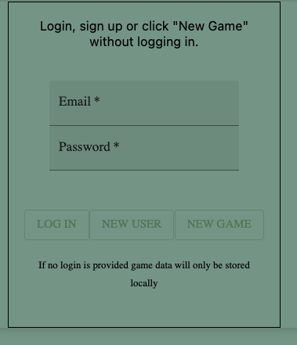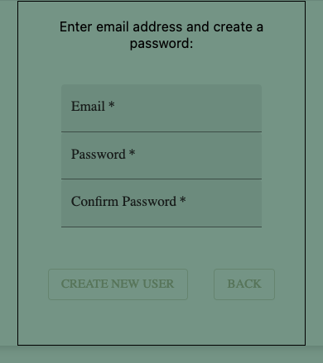

Users will be presented with the login option first (above left). They will have the option to either login or start a new game without logging in. If a user chooses not to create an account their game will not be saved to the backend database and will instead only be saved locally.

Users may also select the “New User” button and may create a new account. The act of signing up will initialize a new game, make a database entry in the user and game tables and direct the new user to the main game screen where they may begin playing immediately.

1.2 - Primary Game Screen

The primary game screen will consist of a title bar and an option menu at the top of the screen.

1.3 Primary Game Play Screens

1.3.1 : Resources and Data Screen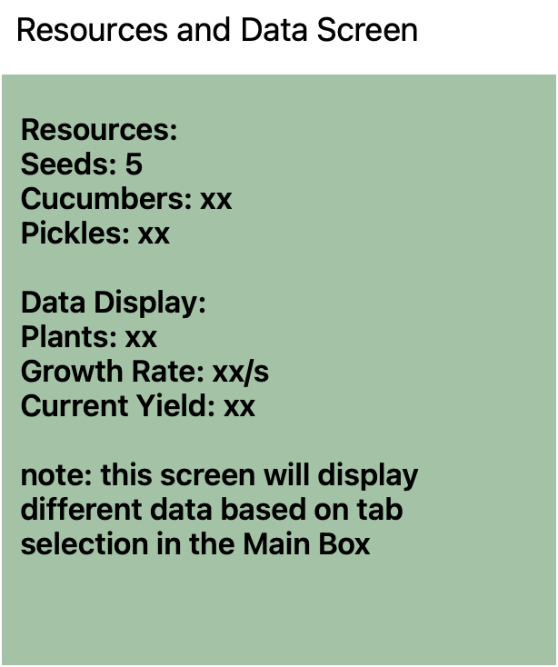

* Displays gameplay information(resources, stats, etc)
* Will be updated once per second by the game engine

1.3.2 : Main Box - Tabbed Navigation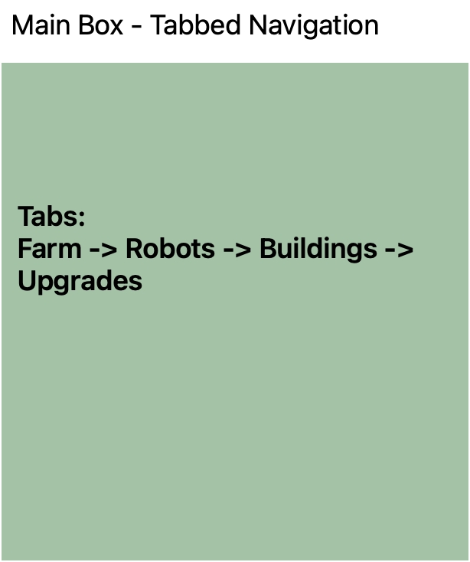

* This is the primary way users will interact with the game.
* The Main Box will have four tabs with each displaying various buttons and options for game play.

1.3.2.1 : Main Box - Farm Tab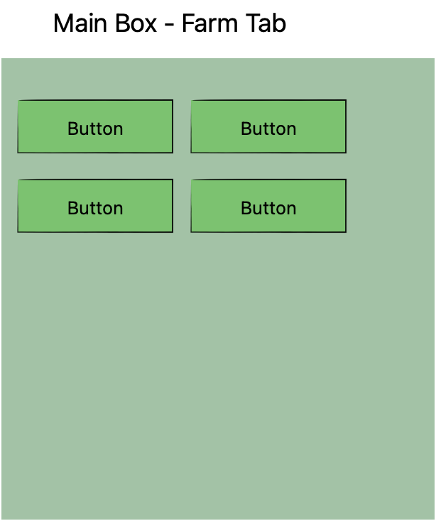

* This is first tab available to users beginning a new game.
  + The Farm Tab will contain the basic iterative clicker buttons used for beginning gameplay.

1.3.2.2 : Main Box - Robots Tab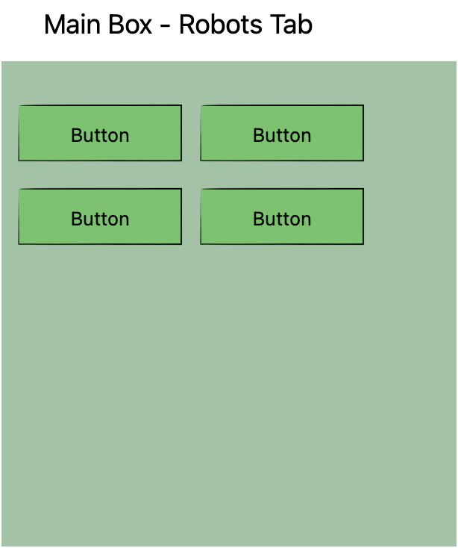

* Users will be able to purchase different types of robots on this tab.
* Purchased robots will begin the automation of the game.

1.3.2.3 : Main Box - Buildings Tab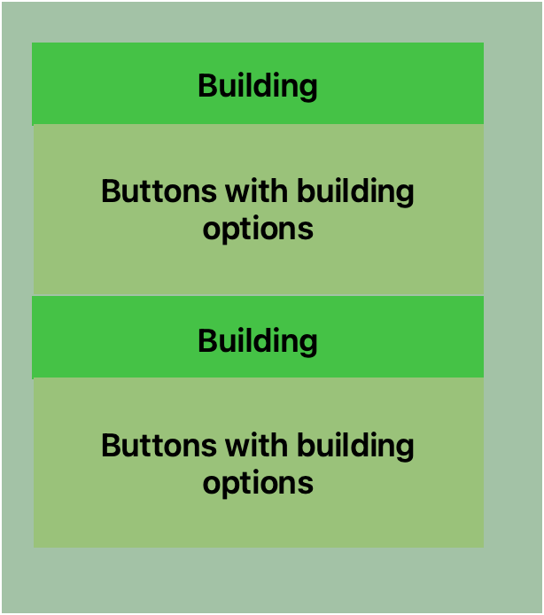

* As gameplay becomes more complex users can purchase buildings that provide certain upgrades.
* Buildings may have settings or options that will be available on this tab.

1.3.2.4 : Main Box - Upgrades Tab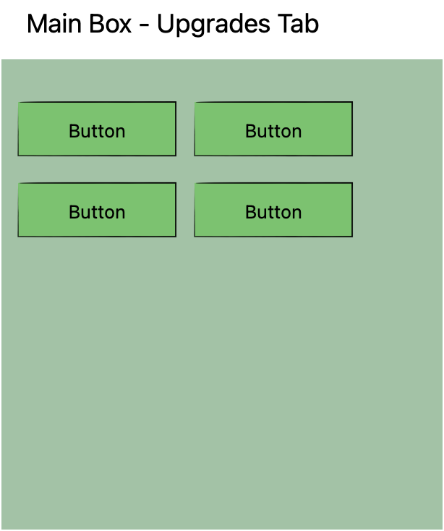

* Users will be able to purchase various upgrades to game play here.
* Upgrades will modify the game in some way or allow users to automate some processes.

1.3.3 : Game log display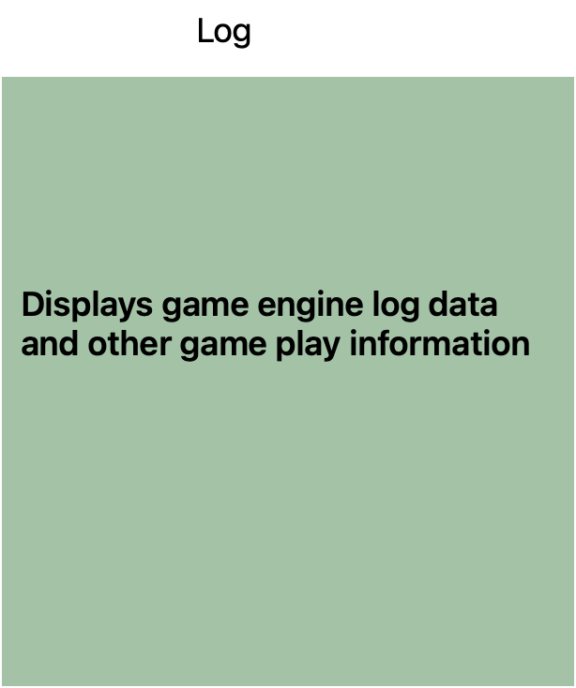

* Displays a regularly updated game log
* Information displayed will include game events, user warnings, game save and other information.

## Project Schedule

| Milestones | Est. Hours | Due Date | Base or Stretch | Completed |
| --- | --- | --- | --- | --- |
| Convert Redux store to use configureStore and CreateSlice | 3 | 10/3/2023 | Base | Complete |
| Create persistent state for local storage | 1 | 10/3/2023 | Base | Not technically feasible as it causes state mutation errors - explore other means of saving a game to local storage |
| Explore adding array maintenance to slice reducers | 1 | 10/12/2023 | Base |  |
| Create visual cues when bots are active | 1 | 10/5/2023 | Base | Partial |
| Add additional stats display for user feedback (show +/- trends for each resource) | 2 | 10/12/2023 | Base |  |
| Create game engine functions for basic game play(Farm Menu) | 3 | 10/4/2023 | Base | Complete |
| Create engine ticker function to update state 1 per second | 2 | 10/5/2023 | Base | Complete |
| Complete User authentication and server route token verification | 3 | 10/8/2023 | Base | Complete |
| Create server routs to load saved games | 1 | 10/9/2023 | Base | Complete |
| Complete Prices reducer structure | 1 | 10/10/2023 | Base | Complete |
| Add ability to purchase Robots | 2 | 10/10/2023 | Base | Complete |
| Incorporate at least one “upgrade” option | 2 | 10/11/2023 | Base |  |
| Incorporate at least one building option | 2 | 10/11/2023 | Base |  |
| Configure number displays to use commas for readability | 2 | 10/13/2023 | Base |  |
| Create UI for showing building settings (based on state var) | 3 | 10/12/2023 | Base |  |
| Reconfigure Mainbox display to use Material UI tabs | 2 | 10/13/2023 | Base |  |
| Review UI Components for styling and visuals | 2 | 10/13/2023 | Base |  |
| Create Settings menu | 2 | 10/14/2023 | Base |  |
| Create About Page | 2 | 10/15/2023 | Base |  |
| Review starting numbers and upgrades for pacing and playability | 5 | Final Base Goal | Base |  |
| Add additional Upgrades | 4 | 10/20/2023 | Stretch |  |
| Add additional Buildings | 4 | 10/21/2023 | Stretch |  |
| Set up additional Material UI Themes | 2 | 10/22/2023 | Stretch |  |
| Set Resources.jsx component to allow display of optional sub-components based on state var | 2 | 10/23/2023 | Stretch |  |
| Expand game to be exponential - turn the planet into pickles | Lots | ∞ | Stretch |  |
| Reconfigure JSONB data into relational accessible data schema | 4 |  | Stretch |  |
| Explore options for local saving of games | 3 | 10/23/2023 | Stretch |  |

# Database Documentation

Robotic Pickle Farm will utilize a Postgres database in order to save logins and game data. The database is solely for saving a users progress through the game. Most game data will be stored using the Postgres JSONB data type to aid in quickly mapping game data to javascript objects.

# Browsers

Robotic Pickle Farm will be tested in current desktop versions of Firefox, Chrome and Safari.

FireFox : 118.0, Chrome: 117, Safari: 16.

# Technologies[nodejs.jpeg](https://nodejs.org/en)[express.jpeg](https://expressjs.com)React_logo.pngredux.pngRedux-Saga-Logo-Portrait.pngmaterialUI.jpeg

